Personal Expense Tracker (iOS) - Development Specification
Development blueprint for a personal iPhone expense tracker using SwiftUI and SwiftData.

Goals
- Record expenses quickly
- Track monthly spending
- Budget monitoring
- Local-first architecture

Technology
Swift
SwiftUI
SwiftData
Swift Charts
MVVM
CloudKit (future)

Core Screens
Dashboard
Add Transaction
Transactions
Reports
Settings

Sample UI
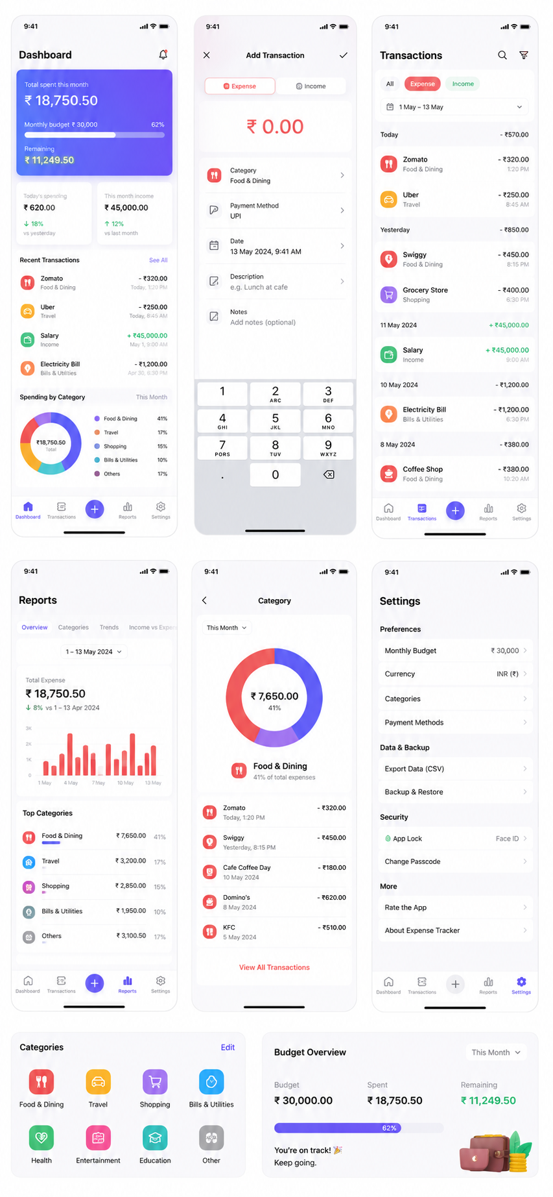

Features
Feature | Priority | Description
Expense Entry | P0 | Quick add
Categories | P0 | Food, Travel, etc.
Reports | P1 | Charts and trends
Budget | P1 | Monthly limits
CSV Export | P2 | Export transactions
Face ID | P2 | Secure access
Cloud Sync | P3 | CloudKit

Data Model
Transaction:
• id
• amount
• type
• category
• paymentMethod
• transactionDate
• merchant
• notes
• createdAt
• updatedAt

Development Roadmap
Phase 1: MVP
Phase 2: Budgets & Reports
Phase 3: Face ID + iCloud
Phase 4: OCR & AI categorization

